**Progress Report**

**- Increment X -**

**Group #7**

*Please use this template to describe your progress on the group project in the latest increment. Please do not change the font, font size, margins or line spacing. All the text in italic should be removed from your final submission.*

# Team Members

*Please write the* ***name*** *of all the team members, their* ***FSU IDs****, and* ***GitHub IDs*** *here.*

Madelyn Yarber, mdy21, MadelynYarber

Meghan Cox, mjc21k, megcoxx

Jacqueline Vermette, jrv23a, JacquelineV-rose

1. **Project Title and Description**

*Briefly describe your project.*

Habit Tracker.

Our project is a habit tracker and task manager in development. The goal of our project is to have a fully developed habit tracker that will allow the users to log on to their account or register an account. After login, then the user will be directed to their habit tracker. Within the habit tracker, the user should be able to view, create, edit, and delete habits that can be assigned daily, weekly, or monthly. The program will record the completed habits and show data based on it. We want there to be a lot of user interactivity and customization.

1. **Accomplishments and overall project status during this increment**

*Describe in detail what was accomplished during this increment and where your project stands overall compared to the initial scope and functionality proposed.*

Our project is in the beginning stages overall. We got the main idea of the front-end development and the initial layout. We created pages and a navigation menu with clickable and working buttons and drop-down lists. We have the dashboard page set up with sections for habits, as well as an editable notes section and motivational quotes. We also have the pages for login and register set up. We are currently working on the database for users.

1. **Challenges, changes in the plan and scope of the project and things that went wrong during this increment**

*Please describe here in detail:*

*- anything that was challenging during this increment and how you dealt with the challenges*

*- any changes that occurred in the initial plan you had for the project or its scope. Describe the reasons for the changes.*

*- anything that went wrong during this increment*

The main challenge was getting the API to be able to safely merge into the main branch on GitHub. The layout was changed because we had to add a new solution into our repo and put the original solution into a separate folder. This caused merge issues.

One change that occurred was the amount of CSS that was used. We were planning to use mainly C#, however, we ended up using much more CSS than planned. The reason is the CSS just flowed easier for the front-end development.

1. **Team Member Contribution for this increment**

*Please list each individual member and their contributions to* ***each of the deliverables in this increment*** *(be as detailed as possible). In other words, describe the contribution of each team member to:*

* 1. *the* ***progress report****, including the sections they wrote or contributed to*

Madelyn Yarber did the progress report and filled out each section. Both Jacqueline and Meghan reviewed and edited.

* 1. *the* ***requirements and design document****, including the sections they wrote or contributed to*

Jacqueline Vermette did the requirements and design document and filled out each section. Both Madelyn and Meghan reviewed and edited.

* 1. *the* ***implementation and testing document****, including the sections they wrote or contributed to*

Meghan Cox did the implementation and testing document and filled out each section. Both Madelyn and Jacqueline reviewed and edited.

* 1. *the* ***source code*** *(be detailed about* ***which*** *parts of the system each team member contributed to and* ***how****)*

Madelyn Yarber did the dashboard layout, including the grid for each of the habits to display, the editable Notes, and the section for motivational quotes. I also worked on the navigational menu on the drop-down bar for Edit Habits include create, edit and delete habits.

Meghan Cox did the API, the Navigation, and the database design. She set up the configuration for Docker and the container for MySQL so everyone can access the database. She also set the navigation functionality and menu up. She set up the API which was needed to access the JSON information that was passed through the server from an HTTP request. She also did the layout for the data page.

Jacqueline Vermette created the login page and registration pages. She used CSS to design these pages. It allows a user to enter input into the text box and or use the register. However, you need to access it using /login or /register to our running server. {login page, register page}

* 1. *the* ***video or presentation***

All of the team members contributed to the video. We all discussed the different topics that we were required to go over. Meghan recorded the demo.

1. **Plans for the next increment**

*If this report if for the first or second increment, describe what are you planning to achieve in the next increment.*

For the next increment we plan to achieve:

* To display all daily, weekly, monthly habits
* A separate page for each daily, weekly, monthly section that displays in detail the habits and the ability mark them as completed
* An ability to add habits to a calendar and display the calendar
* Users have the ability to create, edit, and delete the habits.
* Have a working data page that keeps track of the completed habits
* Possibly allow the users to be able to make their own pages with their own personalized trackers
* Let the user be able to customize the color of certain section backgrounds and maybe change font size

1. **Stakeholder Communication**

*Draft an email communication to the stakeholders of the project succinctly communicating progress and current project status. The email should be intended for a non-technical audience that is expertly aware of the domain your application is designed for. You may not “break the fourth wall” or otherwise refer to the course in the email, instead, you should think about how setbacks or issues you encounter may reflect setbacks that happen in the larger context of production software development and explain them as such. The email should not exceed 500 words.*

Dear Stakeholders,

We are glad to announce that our Habit Tracker is currently running and in progress. Our Habit Tracker and Task Manager is a web API meant for user interactivity, customization, and convenience. We are in the early stages of development. As of now, we have a login and register page for each user who would like to take part in our project. We have now gotten the main page set up and a side navigation bar working for your convenience. We have been successful so far in our front-end development and are now in the stages of progressing into the back-end code of the project. We want our program to be secure with user authentication and hashing of passwords and that is our current objective. We encourage you to continue to have patience with us. We still have a lot of features to implement, and we expect that we will have to troubleshoot any inconveniences as they occur.

1. **Link to video**

{We have the Video Link and the Demo Videos done separately. There are **two** links!}

*Video Link:* <https://youtu.be/ilMzwpWa-84?si=c-6DTgT2M3TEj995>

[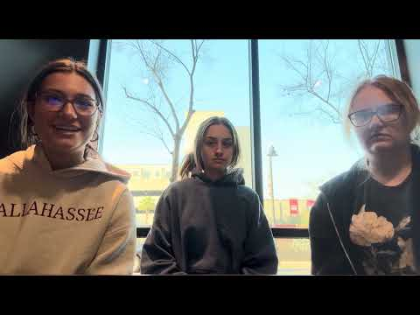](https://youtu.be/ilMzwpWa-84?si=c-6DTgT2M3TEj995)

*Demo:* [*https://youtu.be/EReFn8Err5c*](https://youtu.be/EReFn8Err5c)

[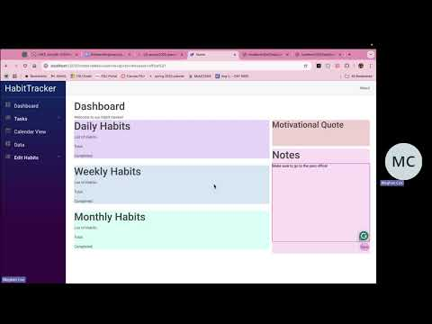](https://youtu.be/EReFn8Err5c)